Making the Most of DonorView
Using DonorView in your Strategic Planning Process

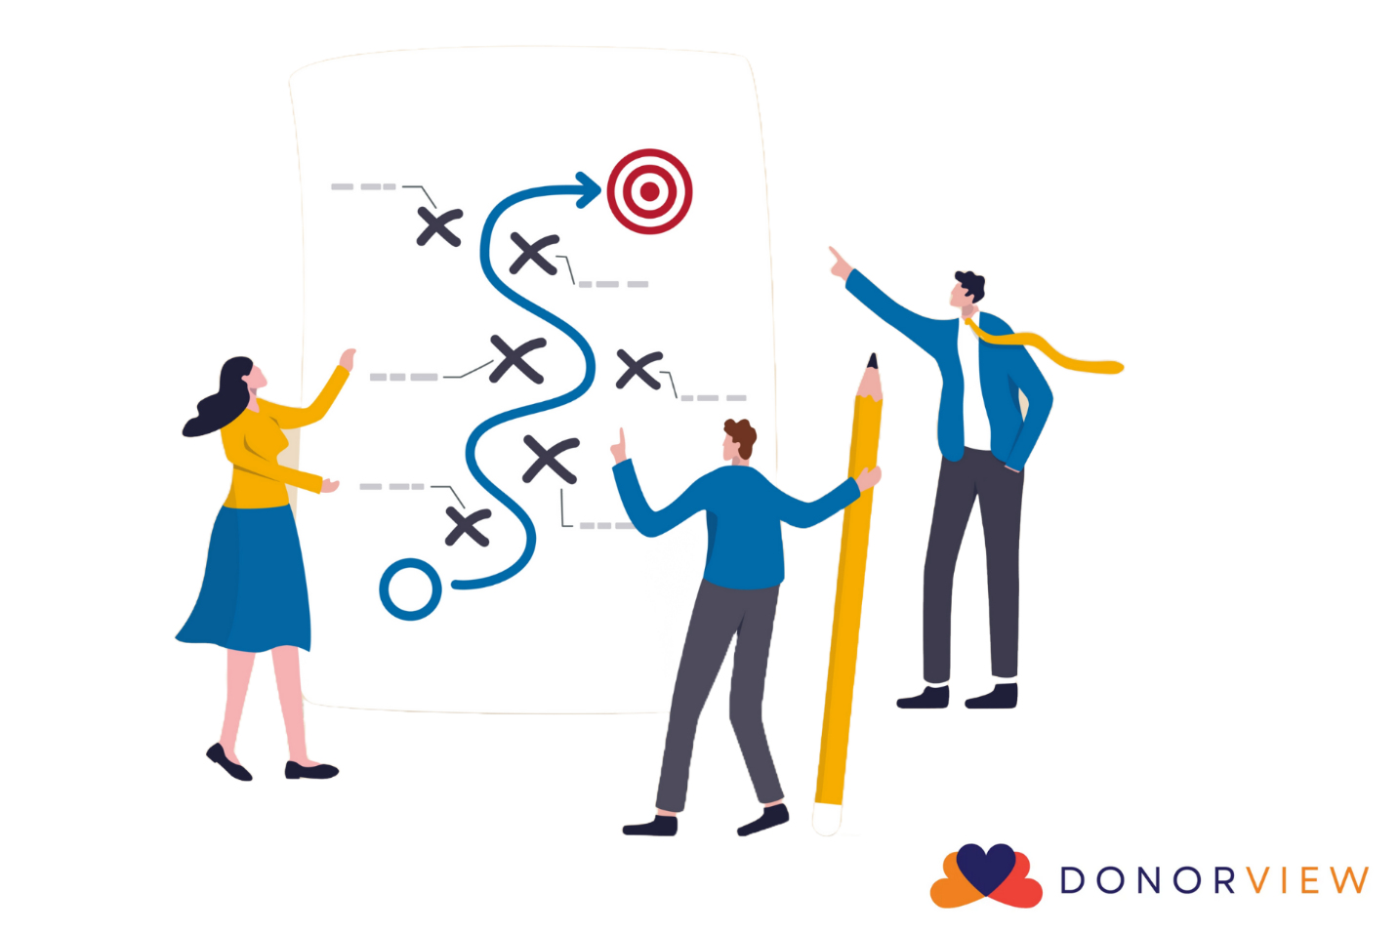

In our next few posts, we will be focusing on strategic and annual planning as well as how DonorView can help you with these processes. We start with strategic planning because the strategic plan sets the path you want to follow and ultimate long-term goal, whereas annual planning lays out the tasks that are performed to achieve the smaller goals set for each year.
Strategic planning requires analysis of where you are and where you want to go. You look at what is happening internally within your organization as well as what is happening external. This is called a SWOT analysis, which stands for Strengths-Weakness-Opportunities-Threats. Strategic planning is usually performed by the leadership team and can take several weeks (or months) to complete. Strategic plans:
- Look at the big picture – the “why”
- Create a map to follow to stay organized and make sure everyone understands the priorities
- Focus on the long-term
- Incorporate your organization’s vision, values, and mission
- Examine external factors that influence your organization
- Use scenarios to evaluate the best course of action
- Identify major objectives to help achieve vision
- Are performed once every 3 – 5 years, but reviewed regularly

You can utilize DonorView in your strategic planning process by using the software to provide the data you need for your analysis, in particular, your fundraising strengths and weaknesses. You can compare things like total amount raised, number of gifts received year to year, average gift size, number of new donors, and donor retention rates. You could also get more detailed information like comparing event proceeds or number of tickets sold. Comparing this data over a few years, you can get a snapshot of the direction you are heading to show if you are improving or seeing a negative trend.
Then, you can take a look at some of the opportunities that DonorView has to offer to help you reach your goals. Perhaps one of your strategies is to improve communication with your donors, so utilizing the email marketing or texting features can help you in this area. Or maybe you want to start getting more corporate sponsors or grants, so integrating the Sponsorships or Grants features in the Fundraising module are tools you can start using. Lots of organizations also want to implement a donor engagement or moves management program, so features like Primary Relationships in the constituent’s profile or Follow Ups can be used to track and plan contact with prospects.
Think about DonorView as an integral part of your analysis and planning process. Not only can it provide information on where you have been, it can also inform where you are heading and help you reach new goals.

